# ECE540 Project 2:

# Rojobot Line-Follower Using PicoBlaze and VGA Controller

# Theory of Operations

## Members: Colten Nye and Hoa Quach

# Introduction

This FPGA project encapsulates the programmatic control of a simulated robot in a simulated world, and the display of the bot and world through a VGA interface.

# Hierarchy:

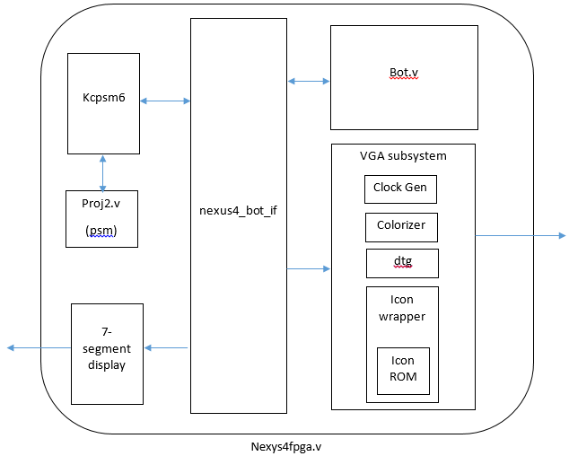

## Nexys4fpga.v

The nexys4fpga module is the top level for the project. It includes all the components of the controller, the bot simulator, the bot-controller interface, and the vga controller, as well as provided utities such as the 7 segment display driver and debouncer. Its inputs and outputs are the various buttons, switches, and LEDs on the board, including the vga port and the system clock.

## Nexys4_bot_if.v

The bot interface allows communication between the PicoBlaze controller, the bot simulator, and the physical inputs/outputs. It takes the asynchronous signal lines from the bot and the switches/buttons and feeds them into the synchronous reads of the PicoBlaze and vise versa.

## vga_subsystem.v

The module vga_subsystem acts as a top module for each of the vga components, including the 25 MHz vga clock generator, the vga timing generator, the icon generator, and the colorizer. The vga_subsystem takes in data from the bot module and feeds it to the icon module, as well as gives data to the bot that it needs for generating the map feed. The vga module then receives this map feed and gives it to the colorizer. Ultimately, the output if this module comes from the colorizer and goes out to the vga port for display.

To have the map be displayed at 512 x 512 pixel as required, we shifted the horizontal and vertical sync signal from the VGA right by 2 ( >>2) before giving it to the bot to read the worldmap’s pixel. This resulted in the worldmap pixel only changing once for every 4 changes of the sync signals. Thus the world map is stretched 4 times.

## Colorizer.v

The colorizer combines the icon feed from the icon module and the world map feed from the bot module. The icon feed takes priority. If there is a pixel from icon that is not transparent, that will be displayed. Otherwise, the map will be displayed. The colorizer contains constants defining the colors associated with the various icon and map codes.

## Clock Generate

This is a piece of IP supplied by Xilinx that was configured to divide the 100 MHz clock down to the required 25 MHz for the VGA system.

## Icon Generation

### Icon ROM

The icon chosen was a picture in the Space Invader videogame. Since the image was fairly simple, we decided to fill in the Coefficient (COE) file manually. We also decided that it’s easier to have 8 icons, one for each orientation. The following is a spreadsheet generated sample of the .coe file (two of eight icons):

|  |  |  |  |  |  |  |  |  |  |  |  |  |  |  |  |
| --- | --- | --- | --- | --- | --- | --- | --- | --- | --- | --- | --- | --- | --- | --- | --- |
| 0 | 0 | 0 | 0 | 0 | 0 | 0 | 0 | 0 | 0 | 0 | 0 | 0 | 0 | 0 | 0 |
| 0 | 0 | 0 | 0 | 0 | 0 | 0 | 1 | 0 | 0 | 0 | 0 | 0 | 0 | 0 | 0 |
| 0 | 0 | 0 | 0 | 0 | 0 | 0 | 1 | 0 | 1 | 0 | 0 | 1 | 1 | 0 | 0 |
| 0 | 0 | 0 | 0 | 0 | 0 | 0 | 0 | 1 | 1 | 1 | 0 | 1 | 1 | 1 | 0 |
| 0 | 0 | 0 | 0 | 0 | 0 | 0 | 1 | 1 | 1 | 1 | 1 | 0 | 1 | 1 | 1 |
| 0 | 0 | 0 | 0 | 0 | 0 | 1 | 1 | 1 | 1 | 1 | 1 | 1 | 1 | 1 | 1 |
| 0 | 0 | 0 | 0 | 0 | 1 | 1 | 1 | 1 | 2 | 2 | 1 | 1 | 1 | 1 | 0 |
| 0 | 1 | 1 | 0 | 1 | 1 | 1 | 1 | 1 | 2 | 2 | 1 | 1 | 1 | 1 | 0 |
| 0 | 0 | 0 | 1 | 1 | 1 | 1 | 1 | 1 | 1 | 1 | 1 | 1 | 1 | 1 | 1 |
| 0 | 0 | 1 | 1 | 1 | 1 | 2 | 2 | 1 | 1 | 1 | 1 | 0 | 0 | 1 | 0 |
| 0 | 0 | 0 | 1 | 1 | 1 | 2 | 2 | 1 | 1 | 1 | 0 | 1 | 0 | 0 | 0 |
| 0 | 0 | 0 | 0 | 1 | 1 | 1 | 1 | 1 | 1 | 0 | 0 | 0 | 0 | 0 | 0 |
| 0 | 0 | 1 | 1 | 0 | 1 | 1 | 1 | 1 | 0 | 1 | 0 | 0 | 0 | 0 | 0 |
| 0 | 0 | 1 | 1 | 1 | 1 | 1 | 1 | 1 | 0 | 0 | 0 | 0 | 0 | 0 | 0 |
| 0 | 0 | 0 | 1 | 1 | 1 | 1 | 1 | 1 | 1 | 0 | 0 | 0 | 0 | 0 | 0 |
| 0 | 0 | 0 | 0 | 1 | 1 | 0 | 0 | 1 | 0 | 0 | 0 | 0 | 0 | 0 | 0 |
| 0 | 0 | 0 | 0 | 0 | 0 | 0 | 0 | 0 | 0 | 0 | 0 | 0 | 0 | 0 | 0 |
| 0 | 0 | 0 | 0 | 0 | 0 | 0 | 0 | 0 | 0 | 0 | 0 | 0 | 0 | 0 | 0 |
| 0 | 0 | 0 | 1 | 0 | 0 | 0 | 0 | 0 | 0 | 0 | 0 | 1 | 0 | 0 | 0 |
| 0 | 0 | 0 | 0 | 1 | 0 | 0 | 0 | 0 | 0 | 0 | 1 | 0 | 0 | 0 | 0 |
| 0 | 0 | 0 | 1 | 1 | 1 | 1 | 1 | 1 | 1 | 1 | 1 | 1 | 0 | 0 | 0 |
| 0 | 0 | 0 | 1 | 1 | 1 | 1 | 1 | 1 | 1 | 1 | 1 | 1 | 0 | 0 | 0 |
| 1 | 1 | 0 | 1 | 1 | 1 | 1 | 1 | 1 | 1 | 1 | 1 | 1 | 0 | 1 | 1 |
| 1 | 1 | 0 | 1 | 1 | 2 | 2 | 1 | 1 | 2 | 2 | 1 | 1 | 0 | 1 | 1 |
| 1 | 1 | 0 | 1 | 1 | 2 | 2 | 1 | 1 | 2 | 2 | 1 | 1 | 0 | 1 | 1 |
| 1 | 1 | 1 | 1 | 1 | 1 | 1 | 1 | 1 | 1 | 1 | 1 | 1 | 1 | 1 | 1 |
| 1 | 1 | 1 | 1 | 1 | 1 | 1 | 1 | 1 | 1 | 1 | 1 | 1 | 1 | 1 | 1 |
| 0 | 0 | 0 | 1 | 1 | 0 | 1 | 0 | 0 | 1 | 0 | 1 | 1 | 0 | 0 | 0 |
| 0 | 0 | 0 | 1 | 1 | 0 | 1 | 0 | 0 | 1 | 0 | 1 | 1 | 0 | 0 | 0 |
| 0 | 0 | 1 | 0 | 0 | 0 | 0 | 0 | 0 | 0 | 0 | 0 | 0 | 1 | 0 | 0 |
| 1 | 0 | 1 | 0 | 0 | 0 | 0 | 0 | 0 | 0 | 0 | 0 | 0 | 1 | 0 | 1 |
| 0 | 0 | 0 | 0 | 0 | 0 | 0 | 0 | 0 | 0 | 0 | 0 | 0 | 0 | 0 | 0 |

The icon ROM was generate using Xilinx Distributed Memory Generator with:

$$Depth = \left(16 px high\right)x \left(16 px wide\right)x \left(2\frac{bits}{pixel}\right)x \left(8 icons\right)= 4096 bits$$

$$Width = 2 bits/pixel$$

### Icon wrapper

The icon wrapper file takes in the X and Y position of the Rojobot and the VGA’s horizontal and vertical sync to calculate address into the icon ROM. The icon Rom then looks up the pixel value stored at that address and returns to the VGA subsystem.

Since we know that the icon is exactly 16x16 pixels, and that the position of the bot occupies a 4x4 pixel grid location, the icon must be drawn at an offset of (16-4)/2 = 6 pixels in the negative x and y directions in order to make the icon center over the bot’s location. Also because we have 8 different images in the ROM, the address into the ROM for each image is simply offset by a multiple of 256 (16x16).

For the icon size, we thought that 16x16 is a good size, therefore the icon was not scaled up. However because the worldmap was scaled up 4 time, the Rojobot’s coordinates and where the icon should be displayed was no longer matched. This was ‘fixed’ by shifting the bot’s coordinates left twice (LocX/Y <<2). This was equivalent to multiply the coordinates of the Rojobot by 4 and thus allowed the bot coordinates’ scale to match with the worldmap’s.

## Other Modules

Other modules were supplied to us and were unchanged, and so require no explanation. These include: kcpsm6.v, debounce.v, sevensegment.v, bot.v, bot_pgm.v, map.v, world_if.v, world_map.v, world_map.ngc, dtg.v, and nexys4fpga_novideo.xdc.

# Tracking algorithm

The Picoblaze psm assembly code was a modification of proj2demo that was provided. Since most of the input and output to ports of the Picoblaze had been provided, they were all reserved as-is in the implementation of the tracking algorithm. In the demo, the Picoblaze wait to read and accept the interrupt from the Rojobot before reading the buttons to generate the next command to the Rojobot. This was done in the ‘next_step’ function of the code. In the actual tracking, the main change is that the Picoblaze has to issue new command base on the information receive from the Rojobot instead of the button. Therefor the ‘next_step’ function is where we put our new algorithm.

The algorithm to allow the robot to make any direction turn is that the robot will first make a 3 x 45 degree left turn (135 degree) to face the left-most direction (relative to its current heading, without turning around completely) then begin a pattern of moving forward, checking for the line, moving back if it doesn’t find it, and turning 45 degrees to the right to repeat the process until it finds the line. This will potentially allow the robot to perform a U-turn if it’s in a dead-end and couldn’t find a turn.

### The Rojobot has 7 states:

* Init: the bot is on a potentially new section of track and will record the current position
* Probe Forward: The bot will try to move forward 1 step
* Forward: The bot found a line and continue to go forward until it’s off the line
* Probe Reverse: the bot didn’t find a line after probing 1 step so it will reverse and try to turn right 45 degrees
* Reverse: the bot takes 1 step back to get back on the line after it went off
* Turn right: the bot turns right 45 degrees
* Turn left 135 degree: the bot turn left 3 time (45 degree each time)

### Psuedo-code algorithm:

if proxi is block

issue LSFS

else

if state = init

store current position

issue LFRF

state = probe_forward

if state = probe_forward

if on the line

issue LFRF

if current position = old position

state = probe_forward

else

state = forward

else

state = probe_reverse

if state = forward

if on the line

issue LFRF

else

isuue LSRS

state = reverse

if state = reverse

if on the line

issue LSRS

state = turnL

read&store curr orient

store #turns = 0

else

issue LRRR

if state = turnL

read curr orient

if curr orient = old orient

issue LSRF

else

update old orient

#turns +1

if #turns = 3

issue LSRS

state = probe_forward

else

continue turn left

if state = probe_reverse

if on the line

state = turnR

issue LFRS

read&store current orient

else

issue LRRR

if state = turnR

read curr orientation

if curr orient = old orient

issue LFRS

else

issue LSRS

state = fowardProbe

## Pathing Bug

We ran into an issue with the right turn only map where our bot would get stuck in an infinite loop. Technically it is not in fact a right turn only map, because there is an extra grid spot that makes a tiny left turn / right turn, but out bot skips this and continues diagonally.

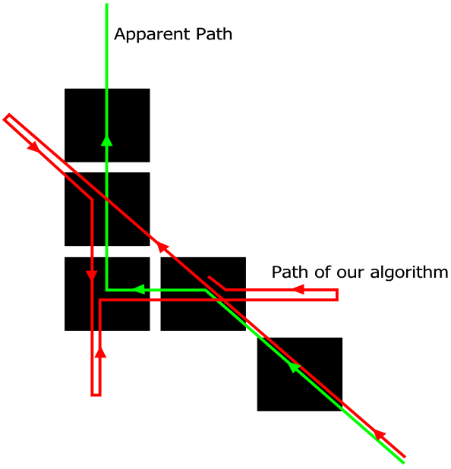

Icon retrieved from:

<http://www.softicons.com/game-icons/space-invaders-pixel-icons-by-dembsky/red-icon>